**ACTIVITY 1 FUNDAMENTALS OF DRAWING**

Name: John A. Lappay

**Portrait**

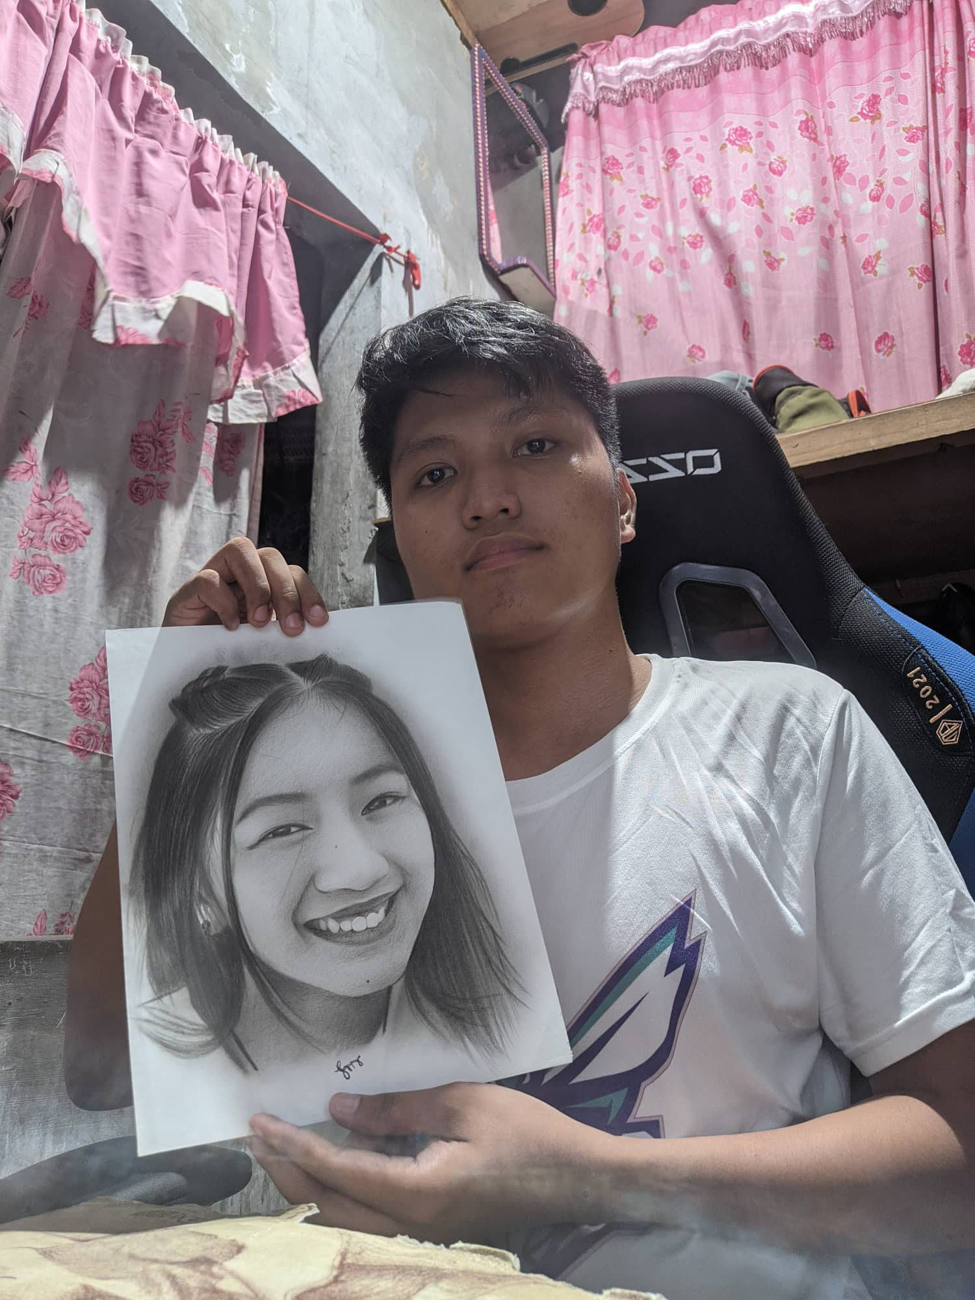

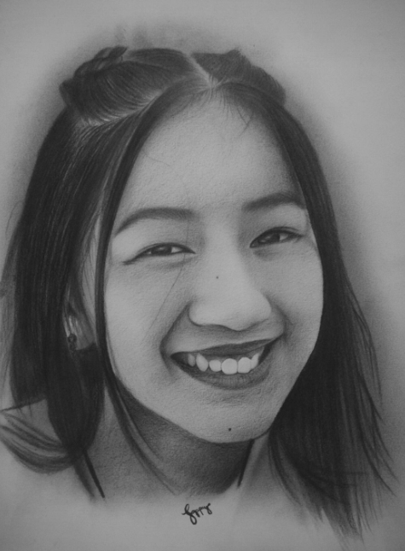

**ONE-POINT PERSPECTIVE**

